It façade pattern after the following benefits. It should client from subsystem components there by reducing the no of objects that clients and making the sub system easier to use.

There by reducing the no of objects

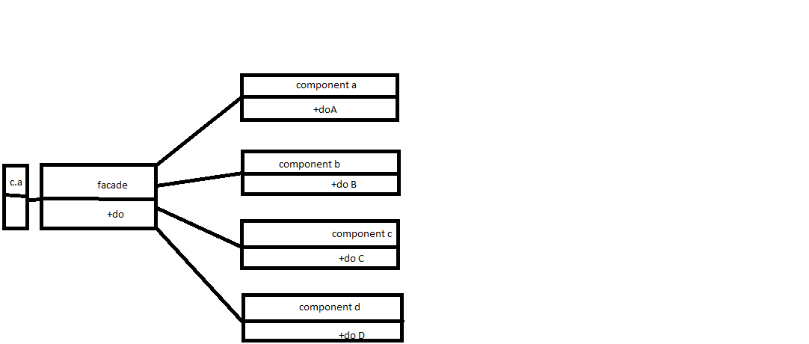

1. It promotes weak coupling in b/w the subsystem and its clients
2. It doesn’t prevent applications from using sub system class

# FIBRACTION:-

PROBLEMS :-

What object should have the responsibility when we don’t want to do whilst and high cohesion and low coupling

## high cohesion

it refers to modules that have functions that are similar in many aspects

### Benefits of high cohesion

1. Red ability
2. Maintainability
3. Reusability

## Low coupling

1. It refers to the module with another module
2. A module is set to be lose coupled if it was independent of any other module

## Benefits of Low coupling

1. testing is easy
2. easy to access

## Solutions ‘